**23.Design DFA using simulator to accept odd number of a’s**

**AIM:** To design DFA using simulator to accept odd number of a’s **TRANSITION DIAGRAM:**

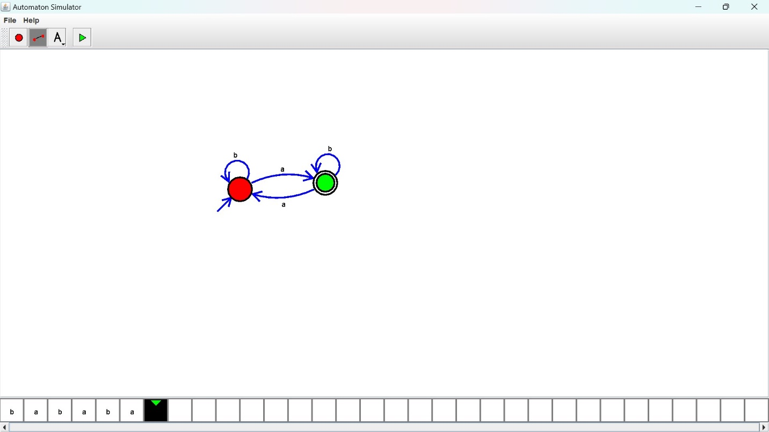

**RESULT:** Hence designed DFA using a simulator to accept the odd number of a’s by using a simulator.